Super Store Excel Dashboarding

* **Data Cleaning** – removal of duplicates, null and inconsistent data
* **Data Manipulation** – creation of new columns and data types
* **Data Aggregation** – creation of pivot tables, lookup, sorting and filtering function to extract insights from the data
* **Data Visualization** – construction of bar, line and pie graph to visualize data.
* **Dashboarding –** Grouping and arranging visualization to get combined valuable insights.
* **Excel Specific** – Coding in VBA for macros, dynamic pivot table and links

**The dashboard includes:**

* **Dynamic KPIs, addition of new data will adjust displayed data**
* **Links to other dashboards within the workbook**
* **Dynamic Pivot Charts with Slicers for filtering of data**
* **Interactive buttons and scroll bar with custom VBA coded macros.**

1. **Overview Page**

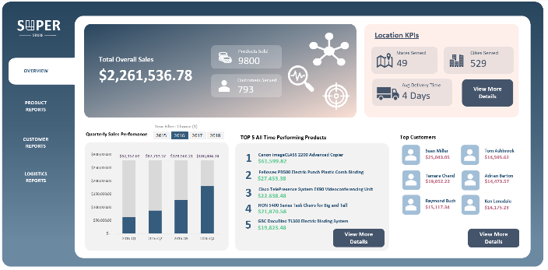

**A**

**B**

**E**

**D**

**C**

1. **General KPI – Total Sales, Total Number of Products Sold, Customers Served**
2. **Location KPI – States and Cities Served, Average Days for delivery**
3. **Quarterly Sales – Sales per Quarter from 2015 to 2018**
4. **Top 5 All-time Selling Product**
5. **Top Purchasing Customers**
6. **Product Reports**

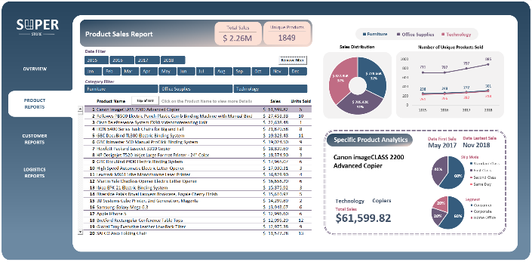

**EC**

**CC**

**F**

**F**

**B**

**A**

**DC**

1. **KPIs – Dynamic summary of Sales and Unique product sold**
2. **Slicers – Date and Product Category Filtering**
3. **Static Charts – summary of sale and yearly product sold per product category**
4. **Interactive list of Products – Dynamic list**
5. **Dynamic Product Summary - Analytics for a specific product**
6. **Buttons – Custom buttons with coded macros**
7. **Customer Reports**

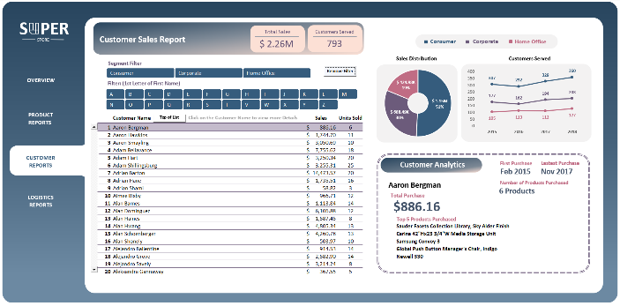

**EC**

**DC**

**F**

**CC**

**F**

**B**

**A**

1. **KPIs – Dynamic summary of sales and customers served**
2. **Slicers – Date and Customer Name Filtering**
3. **Static Charts – summary of sale and customers served per year**
4. **Interactive list of Products – Dynamic list**
5. **Dynamic Product Summary - Analytics for a specific customer**
6. **Buttons – Custom buttons with coded macros**
7. **Logistic Reports**

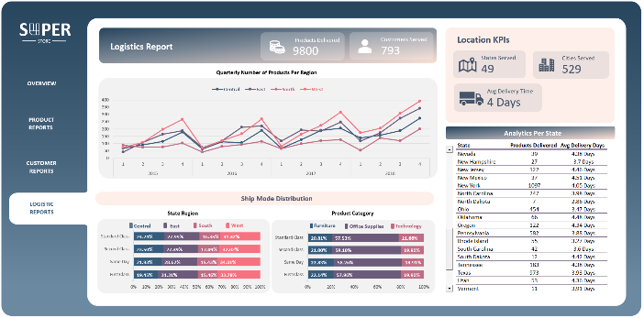

**F**

**E**

**DA**

**CC**

**B**

**A**

1. **KPIs – Products Sold and Customers Served**
2. **Line Chart – Quarterly Number of Products per Region**
3. **Ship Mode Distribution per Region**
4. **Ship Mode Distribution Per Product Category**
5. **KPIs – States and Cities Served, Average Days for delivery**
6. **State Analytics – Summary of Products Delivered and Delivery time per State**